**MKT 6337.002**

**Predictive Analytics using SAS**

**Homework 4 Solutions**

Priyanshi Khatri – pxk173330

**Homework assignment 4**

**Q1. I have given you a panel data on wages (Wage data) in which N=334, T=3 years (1984-1986).**

**For each ID, the data is sorted by year. You need to create the ID and year variables.**

|  |  |  |
| --- | --- | --- |
| **Columns** | **Variable name** | **Description** |
| C1 | Edu | Education in years |
| C2 | Hr | Work hours per year |
| C3 | Wage | Dollar wage per hour |
| C4 | Famearn | Family earnings in dollars per year |
| C5 | Self | Dummy for self-employed |
| C6 | Sal | Dummy for salaried |
| C7 | Mar | Dummy for married |
| C8 | Numkid | Number of children |
| C9 | Age |  |
| C10 | unemp | Local unemployment percentage |

**We need to do a regression to understand the determinants of ln(wage). We need to understand the effect of the following variables: age, edu, numkid, hr, mar, sal, self, unemp.**

1. **Find the best linear regression model. Check for multicollinearity and take appropriate actions.**

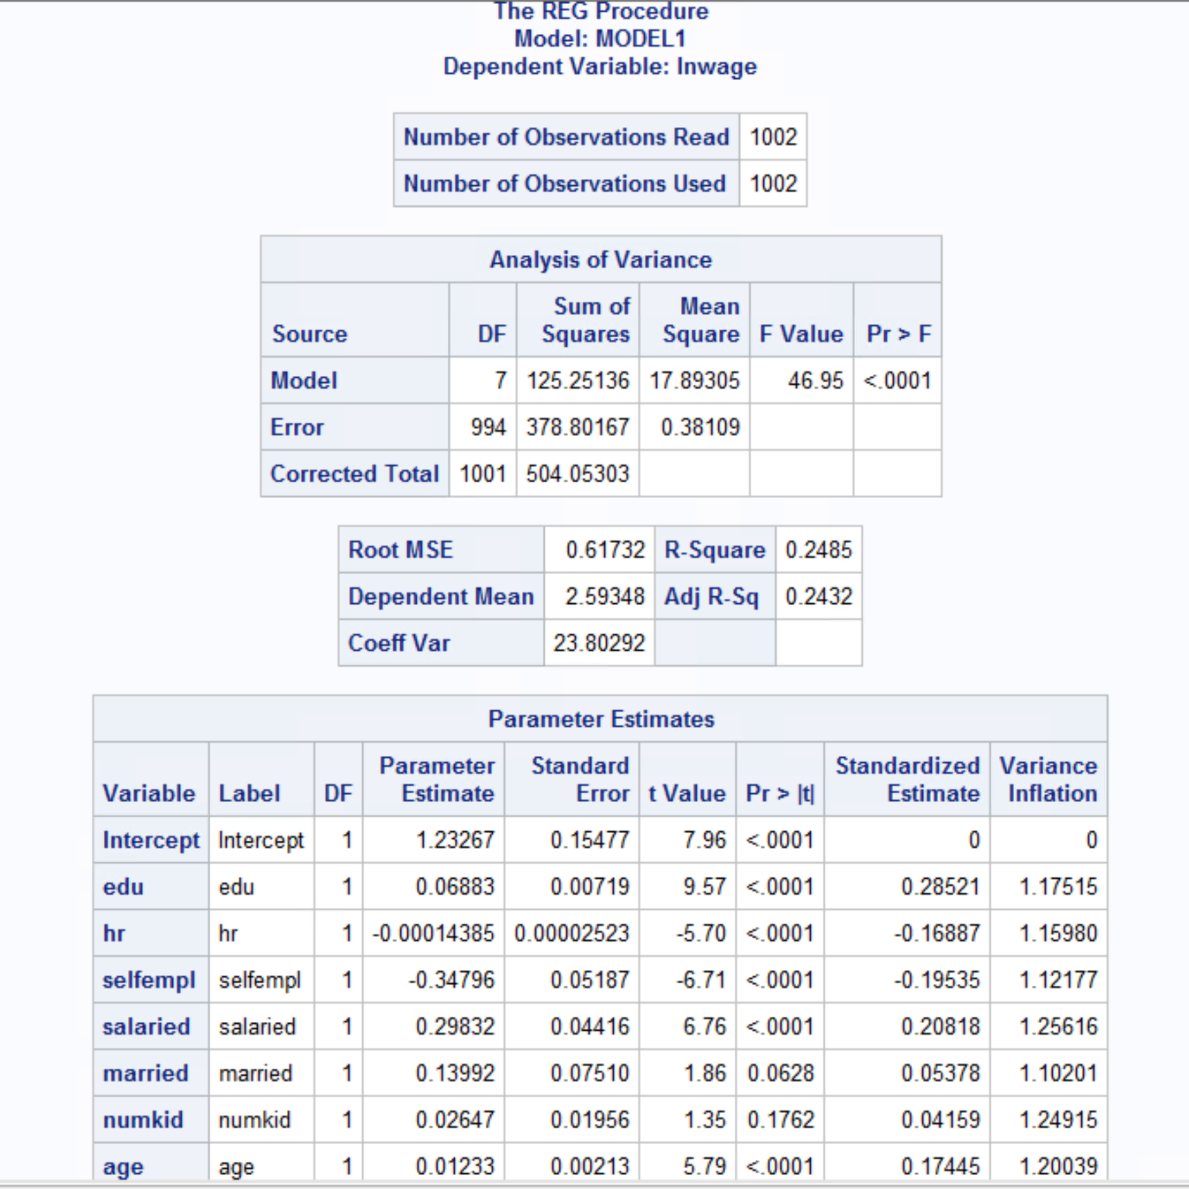

The model with the above independent variables is the best linear regression model. To check for multicollinearity VIF and COLLIN was used. The reason no interaction term was added to the model is that it gave rise to multicollinearity. A variable variance inflation value above 10 is considered to have multicollinearity. From the above model we don’t see any issues with multicollinearity because the vif values are well within range.

The model has an R-square value of 24%. The model isn’t an efficient one as the explanatory variables explain 24% of variance in dependent variables.

To interpret the collinearity diagnostics, the general rule is if one or more of the eigenvalues are small (close to zero) and the corresponding condition index is large. Also, if 2 or more variables have high proportion of variance that indicates multicollinearity.

From the below table we don’t see such scenarios with the variables. Also, from the correlation table the variables do not indicate any hint of multicollinearity. Hence, we can conclude that there is no multicollinearity in the data. If it existed, then one of the possible steps would include eliminating the collinear variable or combining 2 collinear variables into 1.

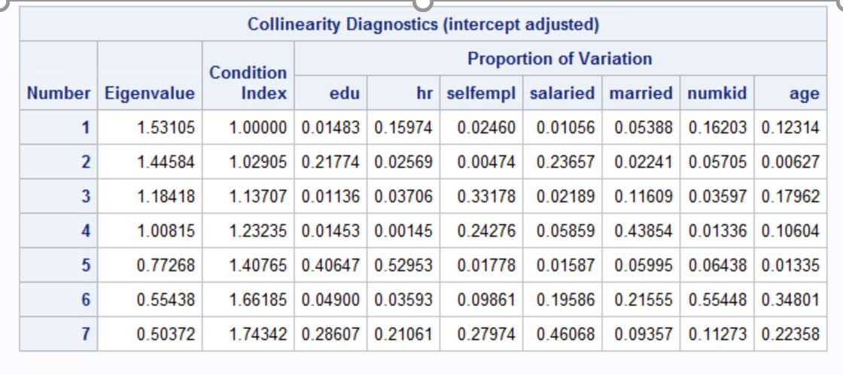

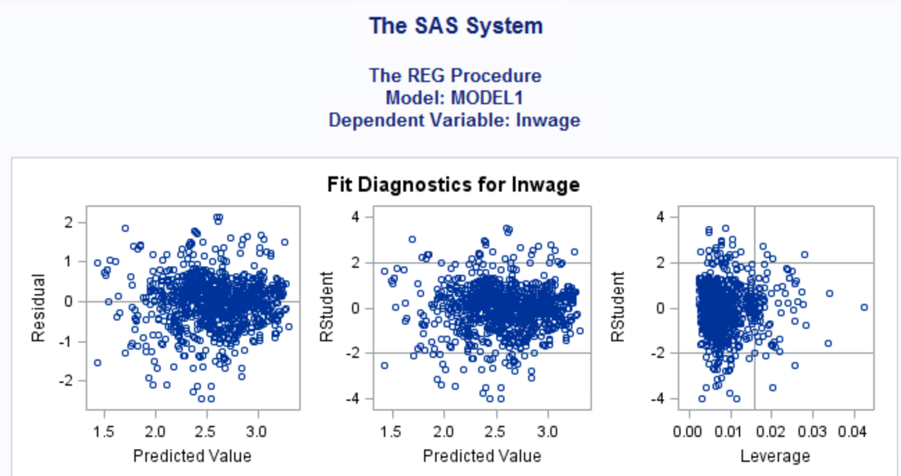

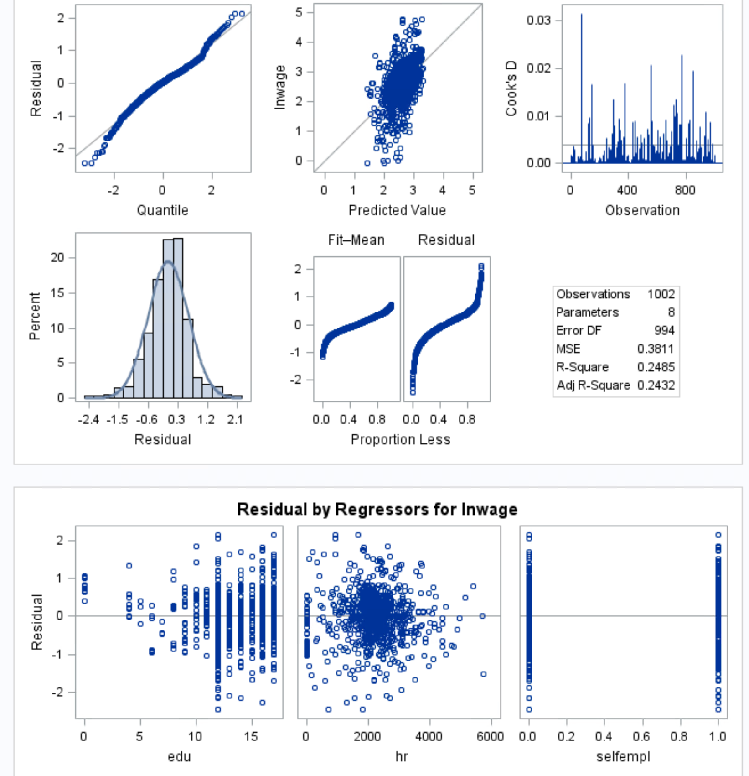

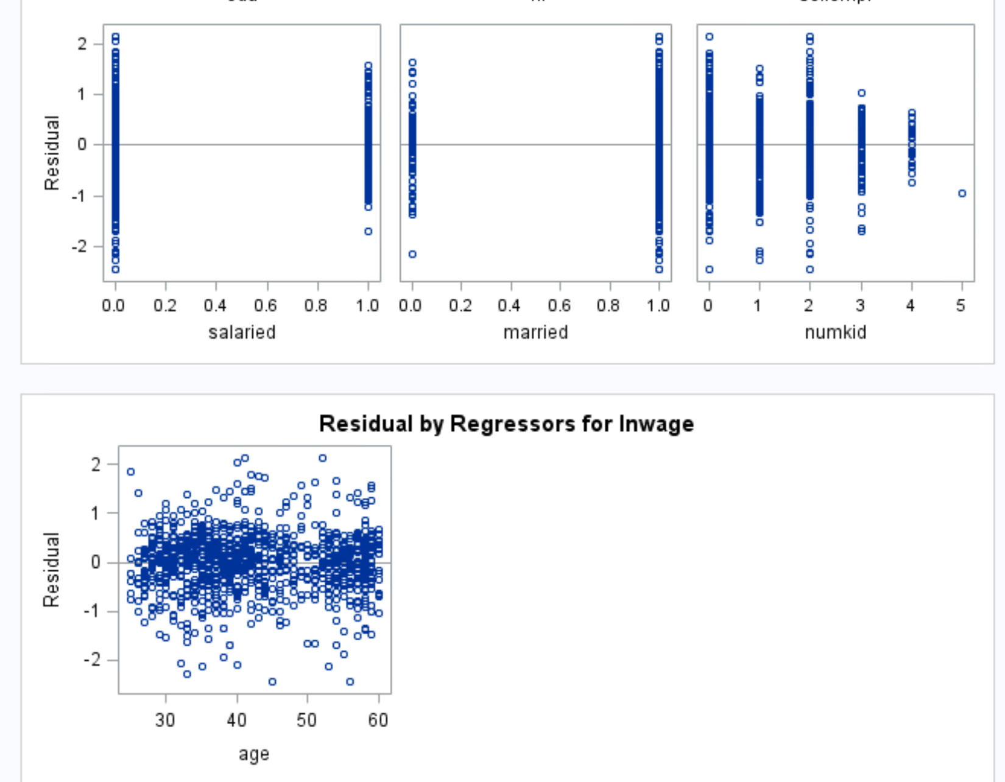

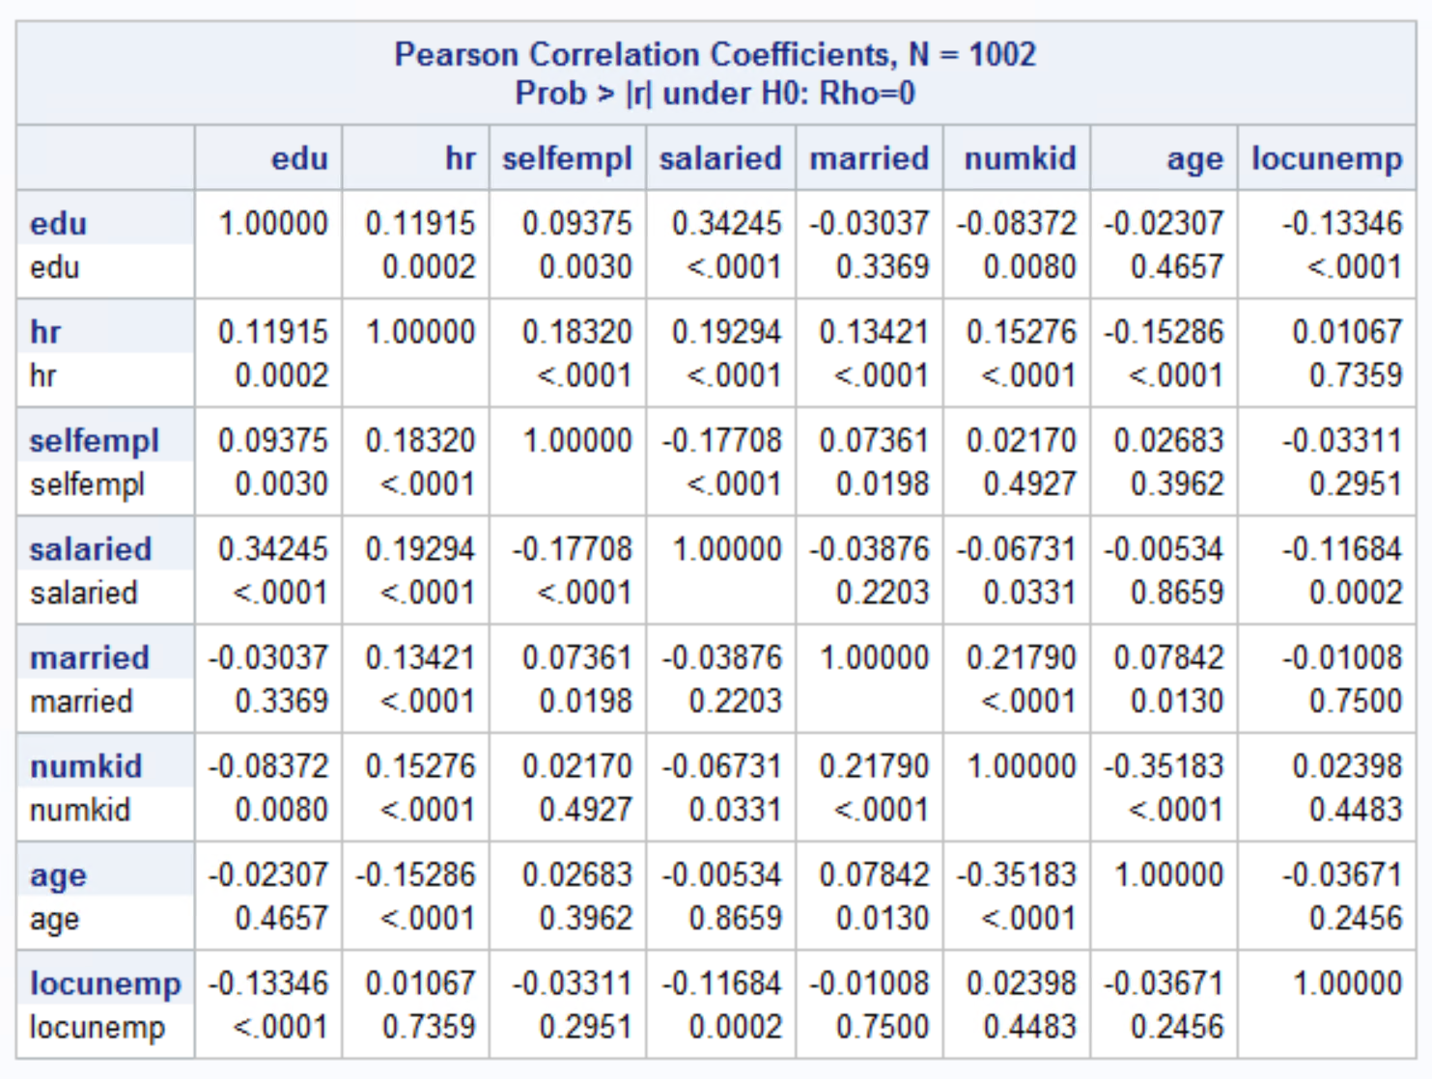

1. **Develop a model to test if there are nonlinear effects for some variables**

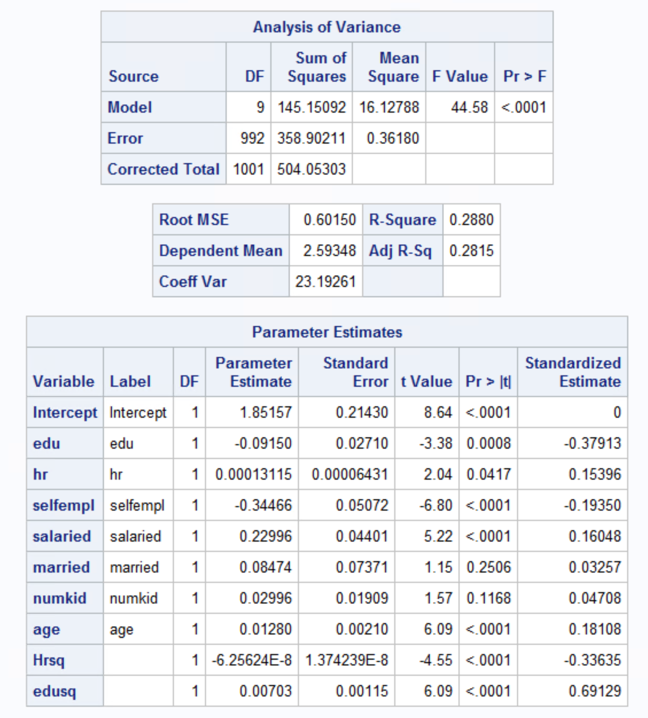

Non-linear effects can be identified by taking a square of a continuous variable and including them model. If both the terms are significant then there is non-linear effect between them. We can see that edu & edusq are both significant. Even hr & hrsq are both significant. There are non-linear effects.

1. **Using the same model, run fixed effects models and random effects models**

**i.e., FIXEDONE, FIXEDTWO, RANONE, RANTWO.**

**Create a table of coefficients side-by side with significant coefficients shown in bold (you may do this in Excel).**

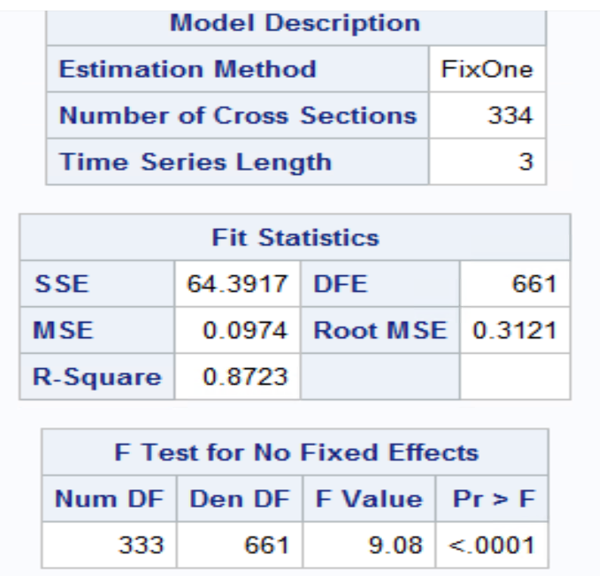

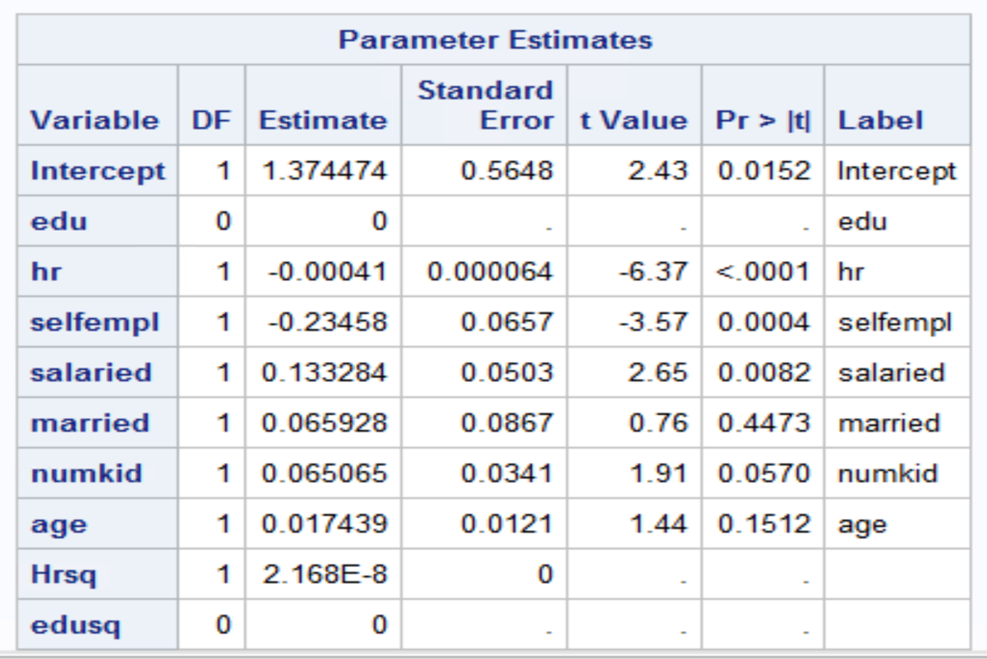

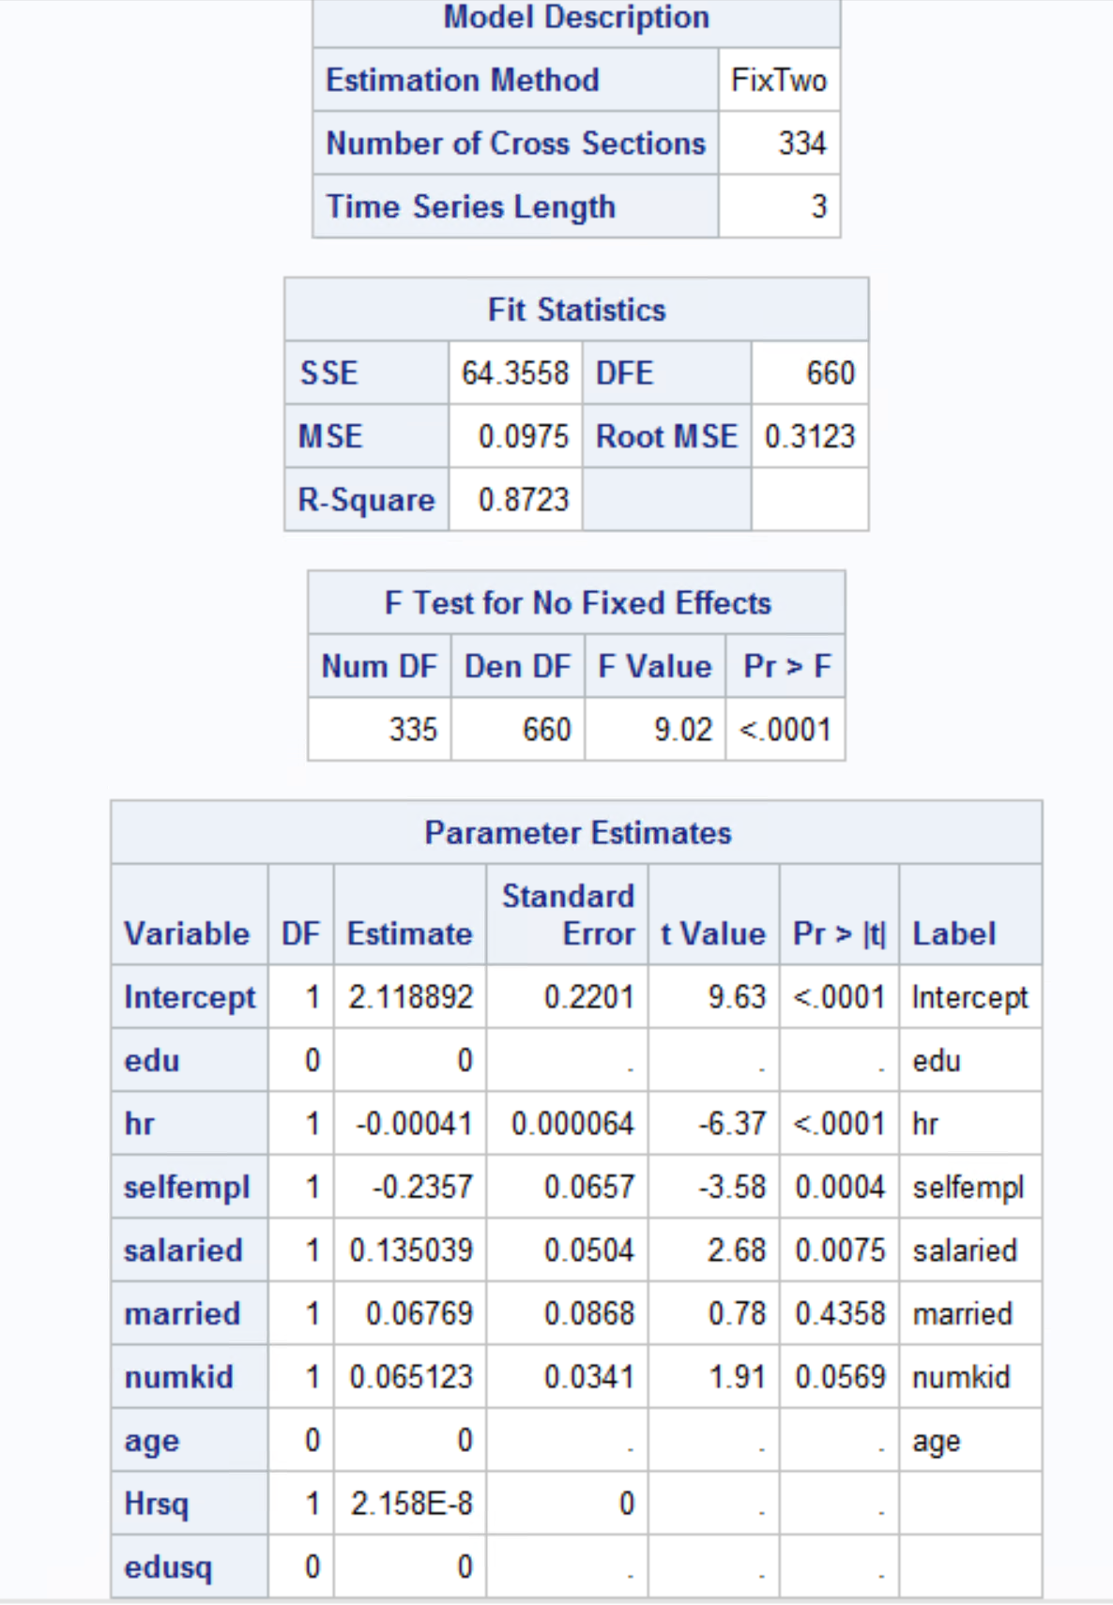

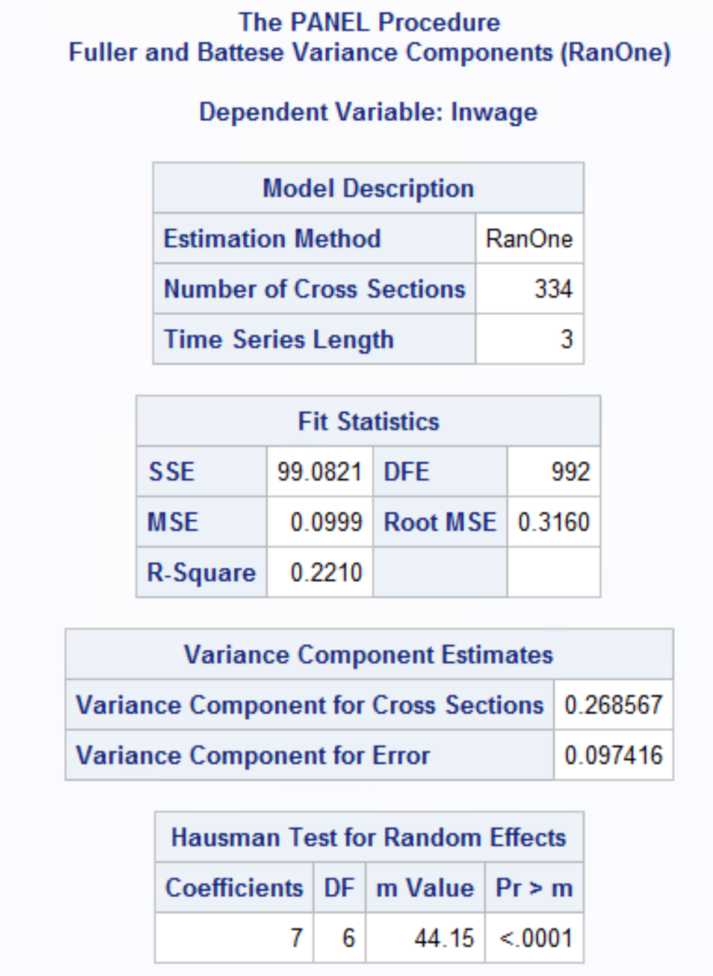

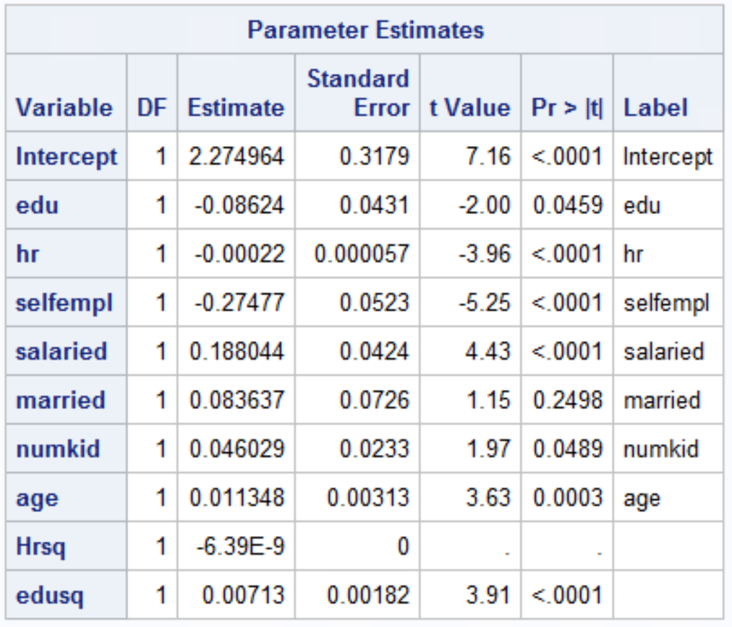

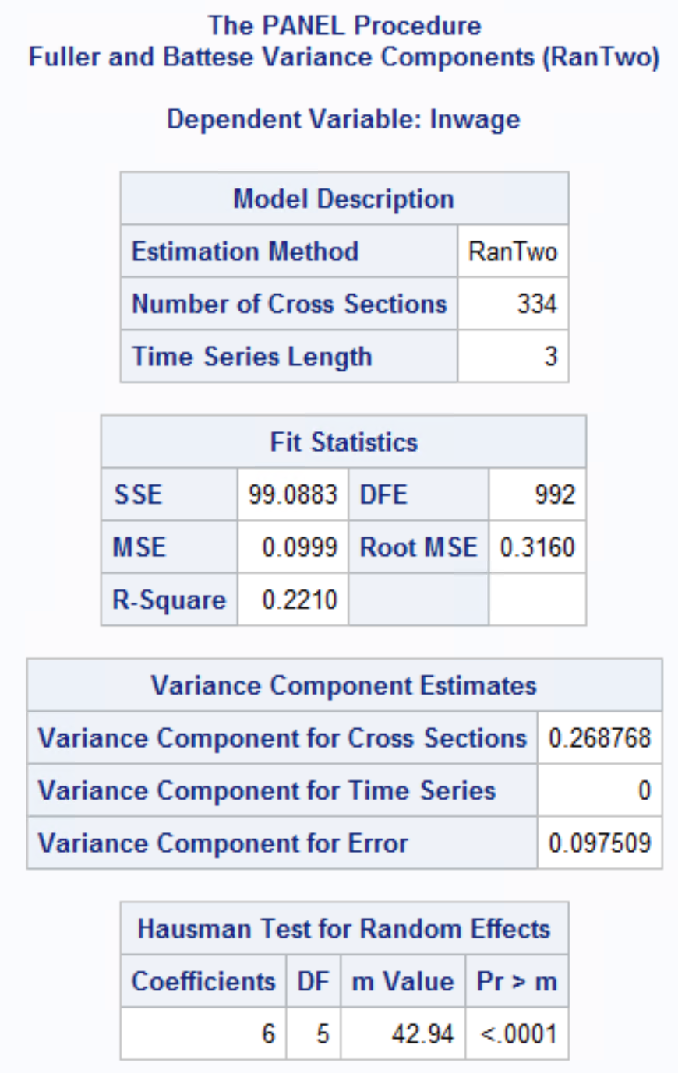

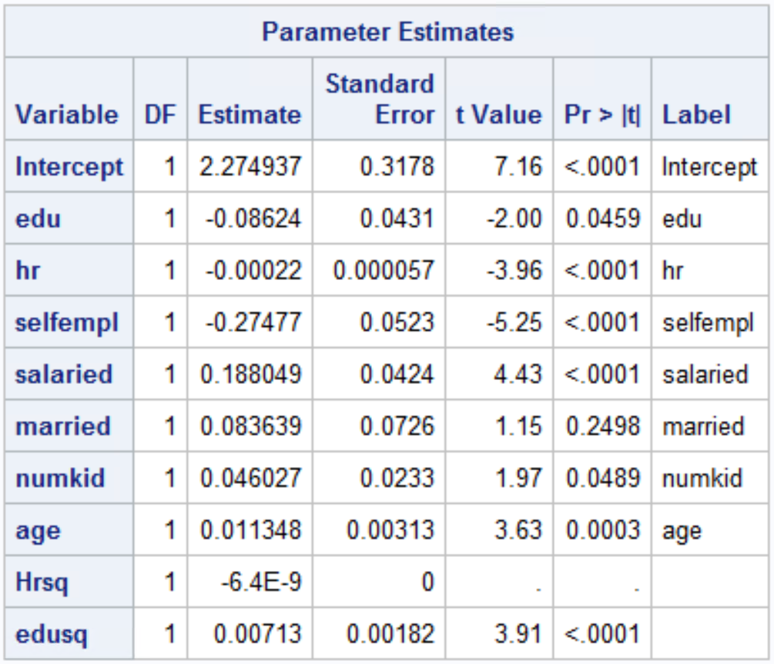

White test with log(wage)-

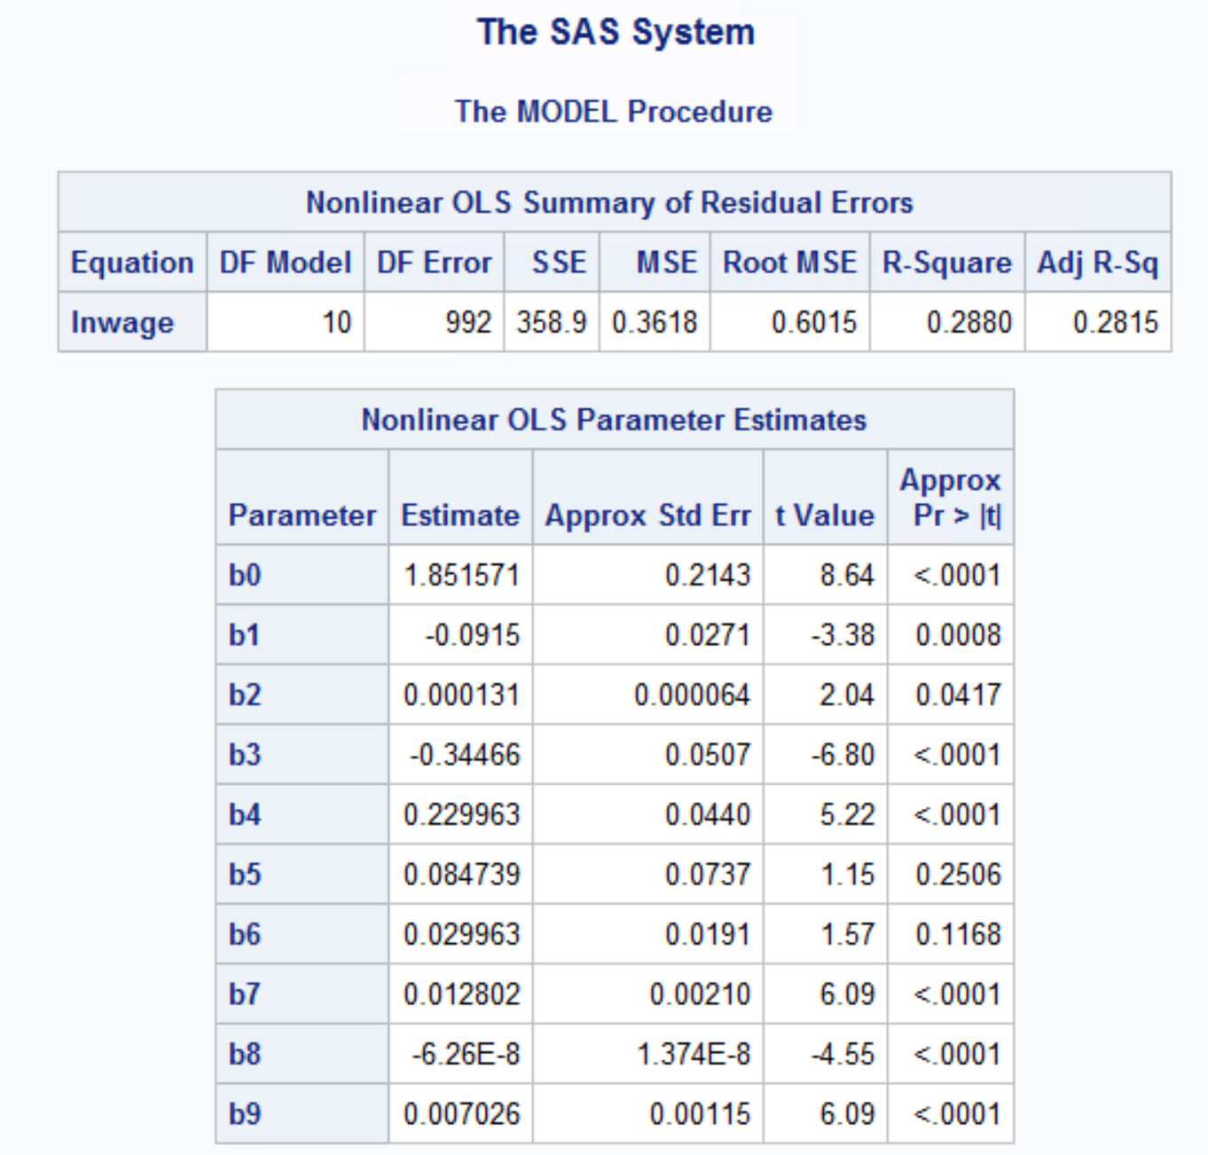

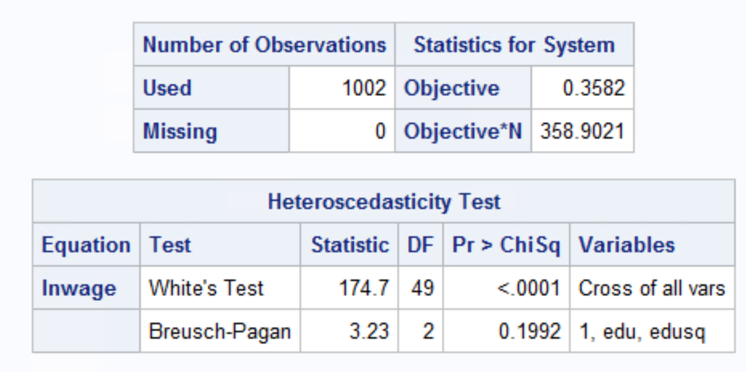

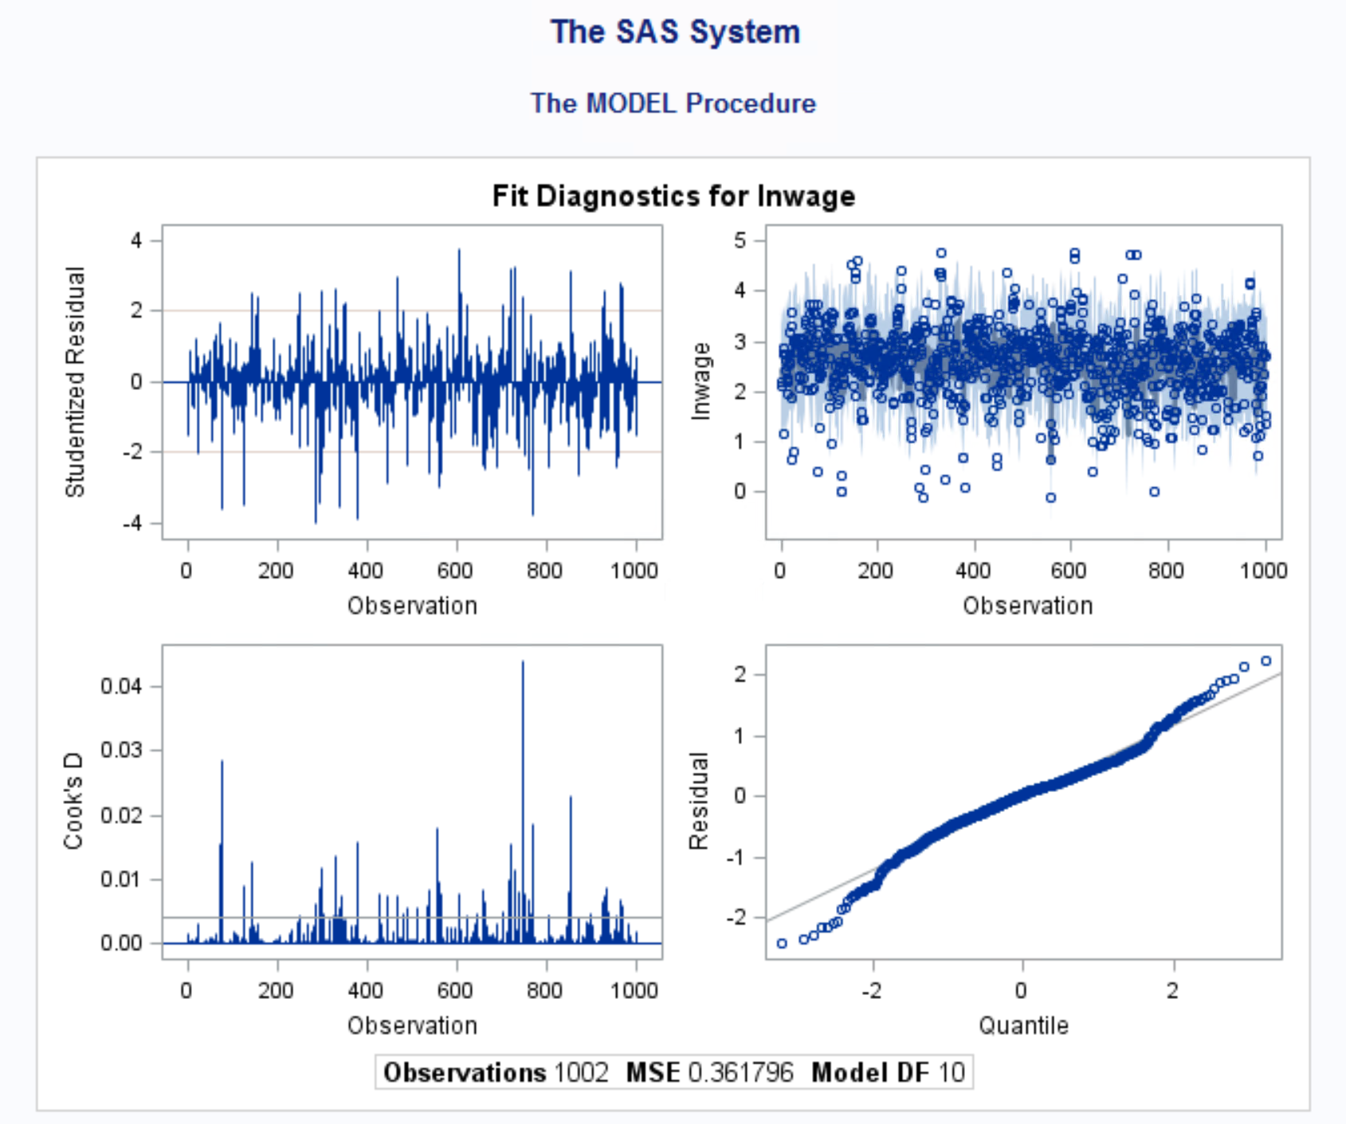

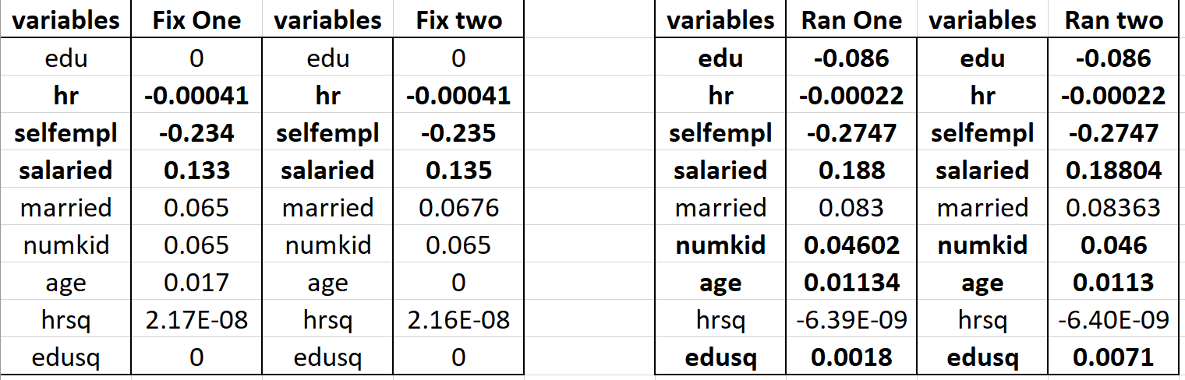

1. **Write a report on your findings. Interpret model fit, t-values, meaning of coefficients, collinearity diagnostics, White test, Breusch-Pagan test etc.**

* Fixed one model – The variables hr, selfempl, salaried are significant variables for this model. -6.37, -3.57, -2.65 are the t-values of the above variables respectively.
* For every 1 hour increase of work per year, the wage decreases by 0.041%. Though the effect of hours is minimal on wage it indicates that adding an additional hour of work might not have a direct impact on the wage. When compared to non-self employed person, a self employed person earns 23.4% lesser. If a person is salaried, then his/her wage per hour increases by 13.3% when compared to a non-salaried person. The fixed one has a model fit of 87.2%. That means 87% of the model is explained by the independent variables. This value indicates that the model is a very good model. It can verified with the good RMSE value as well.
* Fixed two model- The variables hr, selfempl, salaried are significant variables for this model. -6.37, -3.58, -2.68 are the t-values of the above variables respectively. For every 1 hour increase of work per year, the wage decreases by 0.041%. If a person is self-employed, the his/her wage per hour decreases by 23.5% when compared to a non-self employed person. If a person is salaried, then his/her wage per hour increases by 13.5% when compared to non salaried person. The fixed one has a model fit of 87.3%. That means 87% of the model is explained by the independent variables.
* Random one model - The variables edu, hr, selfempl, salaried, numkid, age & edusq are significant variables for this model. -2.00, -3.96, -5.25, 4.43, 1.97, 3.63 & 3.91 are the t-values of the above variables respectively. For every 1-year increase in education, the wage per hour decreases by 8.62%. This can mean that after a point in a person career the value of education has lower impact on wage. For every 1 hour increase in work per year, the wage decreases by 0.022%. If a person is self-employed, the his/her wage per hour decreases by 27.4% when compared to a non self employed person. If a person is salaried, then his/her wage per hour increases by 18.8% when compared to a non salaried person. For every additional kid in the family the wage per hour increases by 4.6%. For every year increase in age, the wage per hour increases by 11.3%. This can indicate that experienced personnel’s are valued more and payed high. The fixed one has a model fit of 87.2%. That means 87% of the model is explained by the independent variables. The model fit good.
* Random two model - The variables edu, hr, selfempl, salaried, numkid, age & edusq are significant variables for this model. -2.00, -3.96, -5.25, 4.43, 1.97, 3.63 & 3.91 are the t-values of the above variables respectively. For every 1-year increase in education, the wage per hour decreases by 8.62%. For every 1 hour increase per year, the wage decreases by 0.022%. If a person is self-employed, the his/her wage per hour decreases by 27.4% when compared to a non self employed person. If a person is salaried, then his/her wage per hour increases by 18.8% when compared to non salaried person. For every additional kid in the family the wage per hour increases by 4.6%. For every year increase in age, the wage per hour increases by 11.3%. This can indicate that experienced personnel are valued more and payed high. The fixed one has a model fit of 22.1%. That means 22% of the model is explained by the independent variables. This isn’t a good model fit.

From the collinearity diagnostics of the linear regression model, the eigen values and it’s corresponding condition index indicates that there is no multicollinearity.

From the Breusch-Pagan test, the variables edu & edusq are not heteroskedastic because the p-value is above 0.05.We can reject the null hypotheses that heteroskedasticity exists.

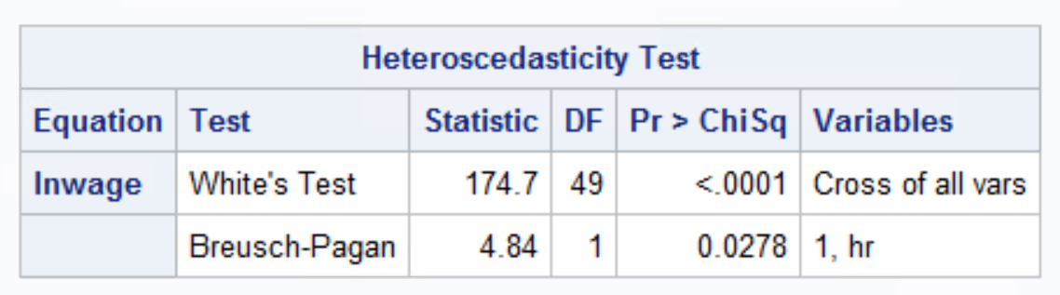

From the above screen grab, we can see that the variable **hr** has p value below 0.05, indicating there is heteroskedasticity.

1. **What is the effect of panel data models on the coefficients. What parameters have changed and by what percentage?**

From fixed effect model to random effects model, few variables which were insignificant became significant. Edu, numkid & edusq variables are significant in random effects where as in fixed intercept it wasn’t. hr, salaried & selfempl variables which are significant in both the models, their coefficients increased in magnitude. In fixed effect models in which the levels of each factor were fixed in advance.

1. **We are especially interested in the effect of education on wages. Notice how much (%) has this coefficient changed across the different models?**

The disadvantage of fixed effect is that it can’t capture the effect of time invariant variables like education. We see the same happening here as well. Education variable which was insignificant in the fixed effects model is now significant in random effects model.

**Q2. I have provided a dataset PIMS.dat which has data on industrial goods manufacturers. The variables in the data are in the following order. These variables and definitions are given in the paper by Robinson and Fornell (1985) on pioneering advantages (see Tables 1, 2 and 3). As in the paper by Robinson and Fornell (1985), we will estimate a simultaneous system of five equations. While the paper considered consumer goods industries, we are interested in replicating the analysis for industrial goods industries.**

|  |  |
| --- | --- |
| MS | Relative market share |
| QUAL | Relative quality |
| PRICE | Relative price |
| PLB | Product line width |
| DC | Relative direct costs |
| PION | Whether a firm is a pioneer (1) or not (0) |
| EF | Whether a firm is an early follower (1) or not (0) |
| PHPF | Pioneer high purchase frequency |
| PLPF | Pioneer low purchase frequency |
| PSC | Pioneer seasonal product change |
| PAPC | Pioneer annual/periodic product change |
| NCOMP | Number of competitors |
| MKTEXP | Relative marketing expenditures (similar to ‘relative advertising and promotion’) |
| TYRP | Twenty year pioneer |
| PNP | Percentage of new products |
| CUSTTYP | Relative customer type |
| NCUST | Relative Number of customers |
| CUSTSIZE | Relative customer size |
| PENEW | Plant and equipment newness |
| CAP | Capacity utilization |
| RBVI | Relative backward vertical integration |
| EMPRODY | Employee productivity |
| UNION | Percentage of employees unionized |

Please estimate a 2SLS model with the following five equations.

model MS=qual plb price pion tyrp ef phpf plpf psc papc ncomp mktexp

model Qual=price dc pion ef tyrp mktexp pnp

model PLB=dc pion tyrp ef pnp custtyp ncust custsize

model Price=ms qual dc pion ef tyrp mktexp pnp

model DC=ms qual pion ef tyrp penew cap rbvi emprody union

Model 1

model MS=qual plb price pion tyrp ef phpf plpf psc papc ncomp mktexp

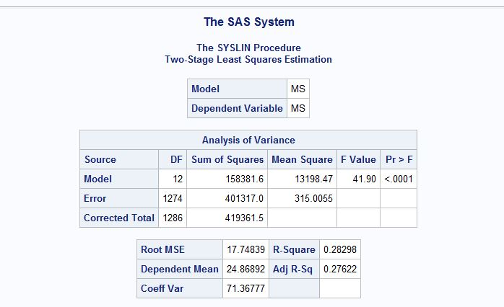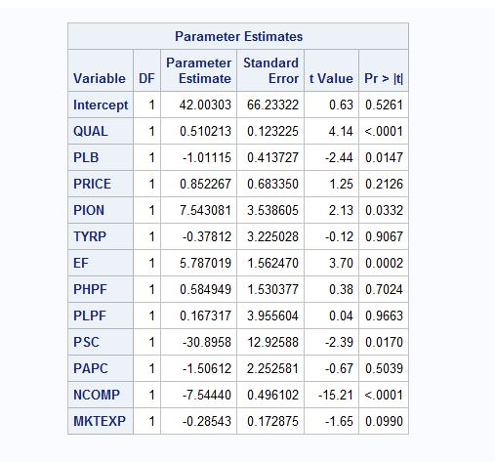

Model 2

model Qual=price dc pion ef tyrp mktexp pnp

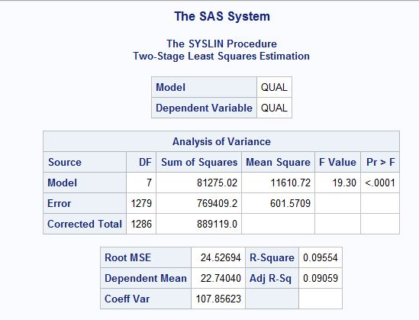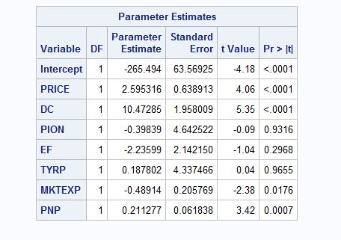

Model 3

model PLB=dc pion tyrp ef pnp custtyp ncust custsize

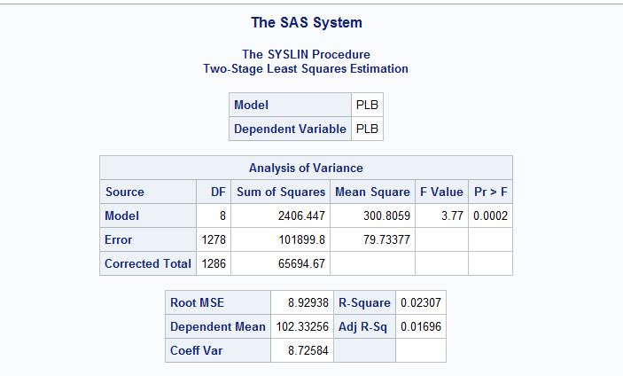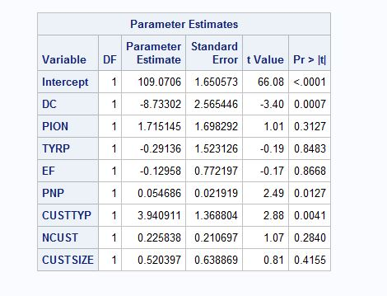

Model 4

model Price=ms qual dc pion ef tyrp mktexp pnp

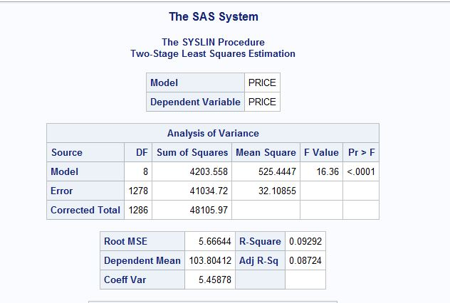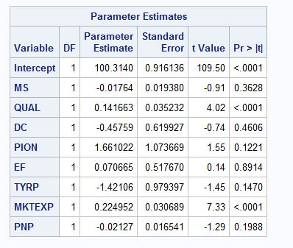

Model 5

model DC=ms qual pion ef tyrp penew cap rbvi emprody union

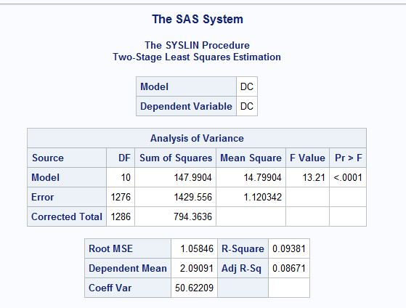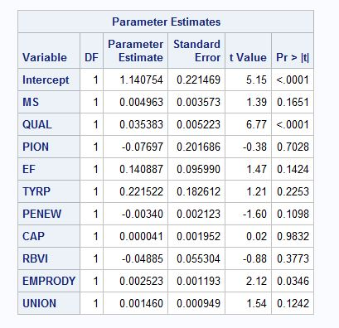

1. Run the 2SLS model using SAS (PROC SYSLIN) and estimate the effect of pioneering on market share. Be sure to consider the direct effects as well as the indirect effects. (read the paper on pioneering advantages for this interpretation).

**Interpretation Model 1 with MS as response variable and PION as the explanatory one:**

The model is significant with F-value 41.90 and p-value less than 0.0001. Adjusted R-square value 27.8% suggests that the model explains 27.8% variation in market share.

Looking at the results of the model, it can also be stated that PION is only significant at 5% significance level only in model 1 where the response variable is market share.

**Effect of PION on Market Share:**

The market share is expected to increase by 7.02 units if the firm is a pioneer in comparison to if the firm is not a pioneer while keeping all other variables in the model constant.

$$\frac{\text{∂ms}}{\text{∂pion}}= βpion+βqual*\frac{\text{∂qual}}{\text{∂pion}}+βplb \frac{\text{∂plb}}{\text{∂pion}}+ βprice* \frac{\text{∂price}}{\text{∂pion}}$$

$$\frac{\text{∂ms}}{\text{∂pion}}=7.54+ 0.51*\left(-0.398\right)-1.011*1.72+0.852*1.66$$

= 7.02

This also makes sense since the innovative product will have space to keep growing until the market gets saturated and the blue ocean turns into red. Therefore, pioneering have advantage in terms of market share.

1. Run a simple regression model of market share as given in the first equation. What is the effect of pioneering on market share using this simple model? How does this effect change across different models?

After running PROC Reg on all the models, we get following estimates and standard errors in comparison to 2SLS:

|  |  |  |  |  |  |  |
| --- | --- | --- | --- | --- | --- | --- |
|  | **Estimates for PION** | |  |  | **Standard Erros for PION** | |
|  | **Simple linear regression** | **2SLS** |  |  | **Simple linear regression** | **2SLS** |
| MS | 12.6 | 7.543 |  | MS | 2.6 | 3.53 |
| Quality | 3.95 | -0.398 |  | Quality | 4.2 | 4.6 |
| PLB | 0.04 | 1.715 |  | PLB | 1.28 | 1.7 |
| Price | 1.6 | 1.661 |  | Price | 1 | 1.07 |
| DC | 0.12 | -0.077 |  | DC | 0.132 | 0.2 |

Using simple regression, we get exaggerated estimates for PION and standard error decreases for most of the variables indicating erroneously higher significance than actual. As for the significance at 5% level, simple regression tells the same story that PION is only significant in the model 1 showing direct effect on relative market share.

**3. Use the churn data to understand what factors are good predictors of churn (i.e. a customer leaving the firm). Churn is the dependent variable that takes the value 1 if a customer has left (cancelled account) and 0 otherwise.**

**There are 100,000 observations in the data. Take a random sample of 50% of the data using PROC SURVEYSELECT. Use one half of the sample for estimation of parameters (training sample) and the other half for prediction (test sample).**

**We need to use a logistic regression model, since Y is a binary discrete variable. Use the following website as a reference for doing the exercise:**

[**http://www.ats.ucla.edu/stat/r/dae/logit.htm**](http://www.ats.ucla.edu/stat/r/dae/logit.htm)

**Make sure that there are no two explanatory variables that are highly correlated. Use correlation analysis to determine the correlation between the variables. Write a report explaining what are the top 5 factors that predict churn. Comment on model fit, interpret the effect of a continuous variable and a discrete variable (at the least), interpret odds ratios, percentage concordant etc.**

**Predict whether a customer will churn in the test sample and report how accurate is your prediction in terms of percentage of accurate predictions (e.g. 70%).**

**Ans:**

Firstly, checked the missing values of all the continuous variables and dropped the variables with more than 60% missing values.

Also, checked the missing frequency of categorical variables and dropped them.

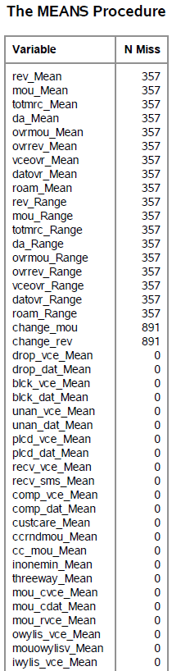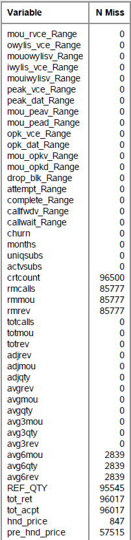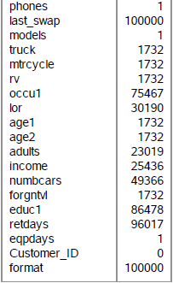

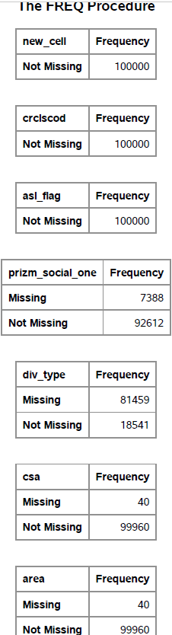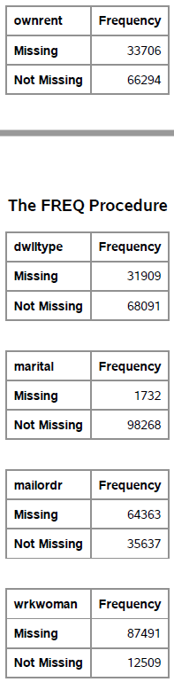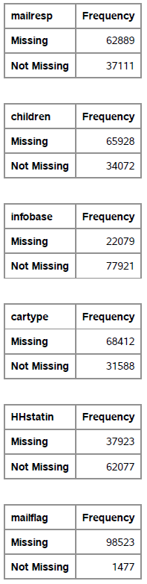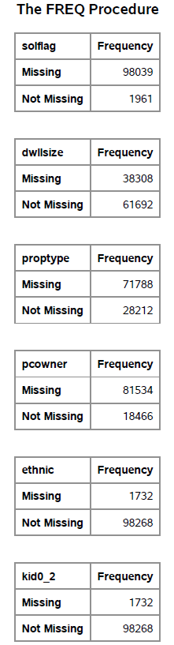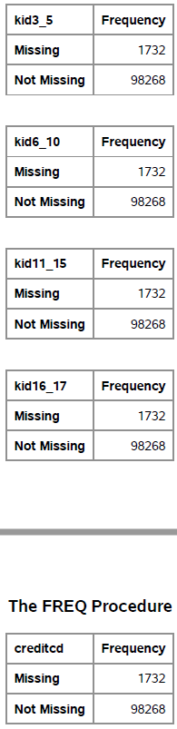

Finally, the variables that were dropped are – mailordr, wrkwoman, div_type, proptype, pcowner, mailflag, solflag, mailresp, cartype, crtcount, rmcalls, children, rmmou, rmrev, REF_QTY, tot_ret, tot_acpt, pre_hnd_price, last_swap, occu1, numbcars, educ1 and retdays.

From below output we choose which variables have the high significant percentage difference between the means for class churn (for continuous variables)

Variables with high percentage of mean difference are – Roam_Mean, Roam_Range, change_mou, change_rev, drop_dat_Mean, blck_dat_Mean, custcare_Mean, threeway_Mean, mou_opkd_Mean, callfwdv_Mean, blck_dat_Range.

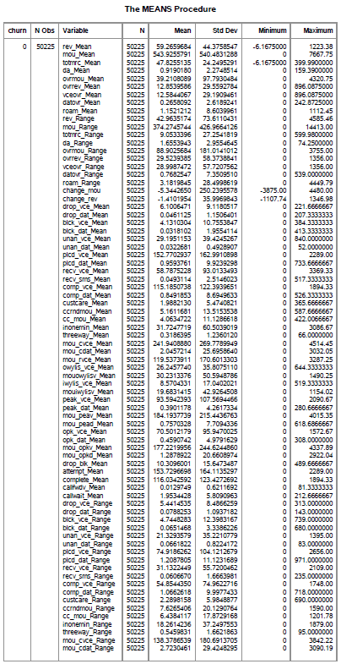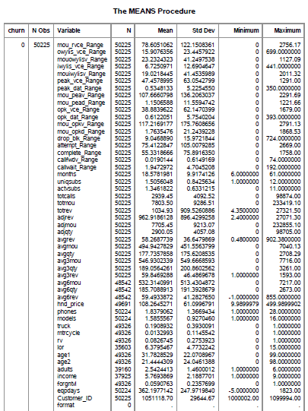

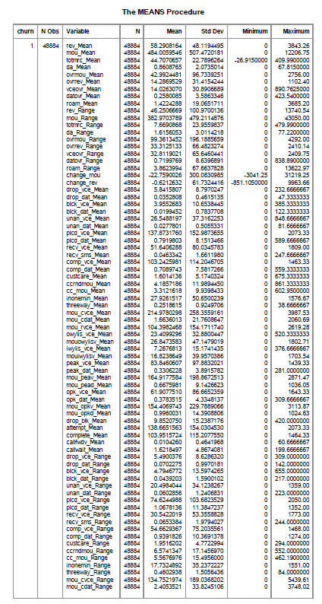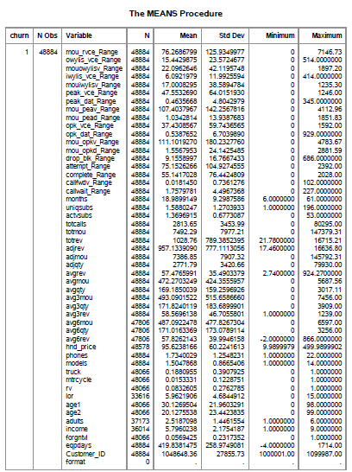

Then, Correlation analysis is performed to make sure no two explanatory variables are highly correlated.

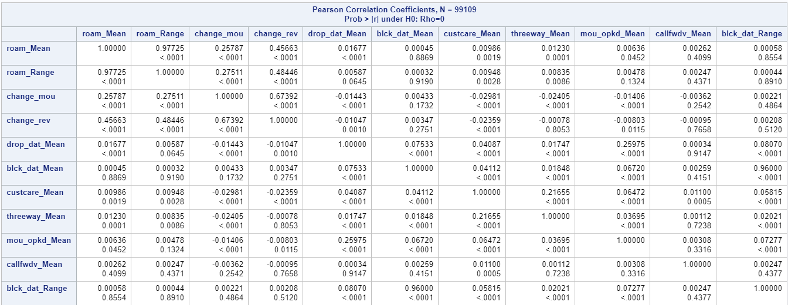

Out of the variables which are highly correlated, only one of them is kept in the model. Logit regression model is used as the dependent variable churn is binary and takes values 1 and 0.

Proc Surveyselect is used with simple random sampling method to create test and train data with 50% sampling rate.

Next, Logistic regression is run on the trainset dataset using the different combinations of significant factors affecting churn. The model with maximum concordance ratio is considered for churn prediction.

**The final model has a concordance ratio of 61.3%**

**The top 5 variables in prediction of churn are**: -

1. mou_Mean: - Mean number of monthly minutes of use

The increase in mean monthly mou is a good predictor of customer’s satisfaction and unlikeliness to leaving. (-ve coefficient)

1. mou_Range: - MOU range
2. eqpdays: - Number of days (age) of current equipment

The customer is more prone to churn if the current equipment is aged ie. the current handset’s contract period has ended.

1. totrev: - Total revenue
2. change_mou: - Percentage change in monthly minutes of use vs previous three-month average

The customer is more prone to churn if the current mou has decreased as compared to last 3 months mean. A declining MOU might be a reason unhappiness & switching to another service provider.

**The train dataset accuracy with the logistic prediction model is 57.5% And with the test dataset, it is 59.4%. There is still a lot of scope of improvement.**

